CHAPTER FOUR

SYSTEM IMPLEMENTATION AND RESULTS

4.1 Introduction
The implementation phase of Agri-Go represents the physical realization of the design specifications established in the previous chapter. This stage involves the translation of logic into executable code, the training and deployment of deep learning models, and the configuration of a scalable database architecture. This chapter provides a detailed account of the technical environment, the implementation of core functional modules, and an analysis of the results obtained during system testing.

4.2 Implementation Environment
The development of Agri-Go followed a hybrid stack approach to balance the high-performance requirements of AI with the real-time needs of a marketplace.

4.2.1 Hardware Requirements
- Development Unit: Intel Core i7 processor with 16GB RAM and an NVIDIA GTX 1650 GPU for local model training.
- Deployment Target: Cloud-based VPS with support for Python environments and Node.js runtimes.

4.2.2 Software Architecture (MERN-P Stack)
The system utilizes the MERN-P stack, a variation of the traditional MERN stack that includes Python (Flask) for machine learning services.
- React.js (Frontend): Handles the dynamic UI, state management for the marketplace, and the farmer’s dashboard.
- Node.js/Express (Backend): Manages relational data, order processing, and user authentication.
- MySQL (Database): Chosen for its ACID compliance, which is critical for handling financial transactions and inventory integrity in the marketplace.
- Flask (AI Engine): Acts as the bridge between the React frontend and the TensorFlow/Keras models.

4.3 UI Implementation and Interface Showcase
The interface was designed with a focus on high-contrast accessibility for farmers operating in outdoor environments.

4.3.1 Authentication and Landing
The first point of interaction is the landing page, which introduces the user to the core services: Diagnostics, Trade, and AI Support.
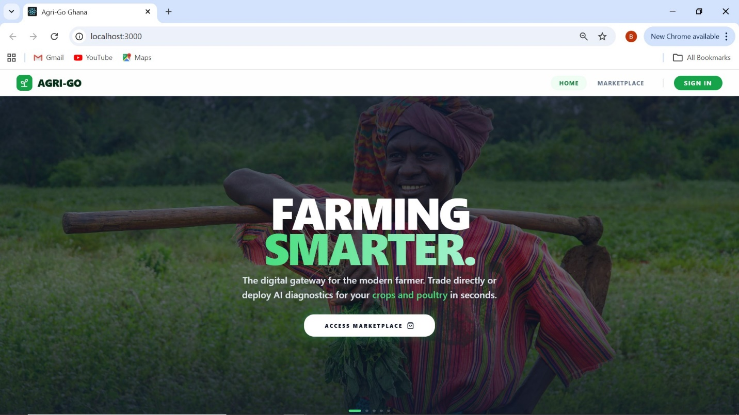[IMAGE 1: Homepage]
Users must authenticate to access the specialized dashboards. The registration logic ensures that users are categorized correctly to prevent unauthorized access to farmer-specific inventory tools.
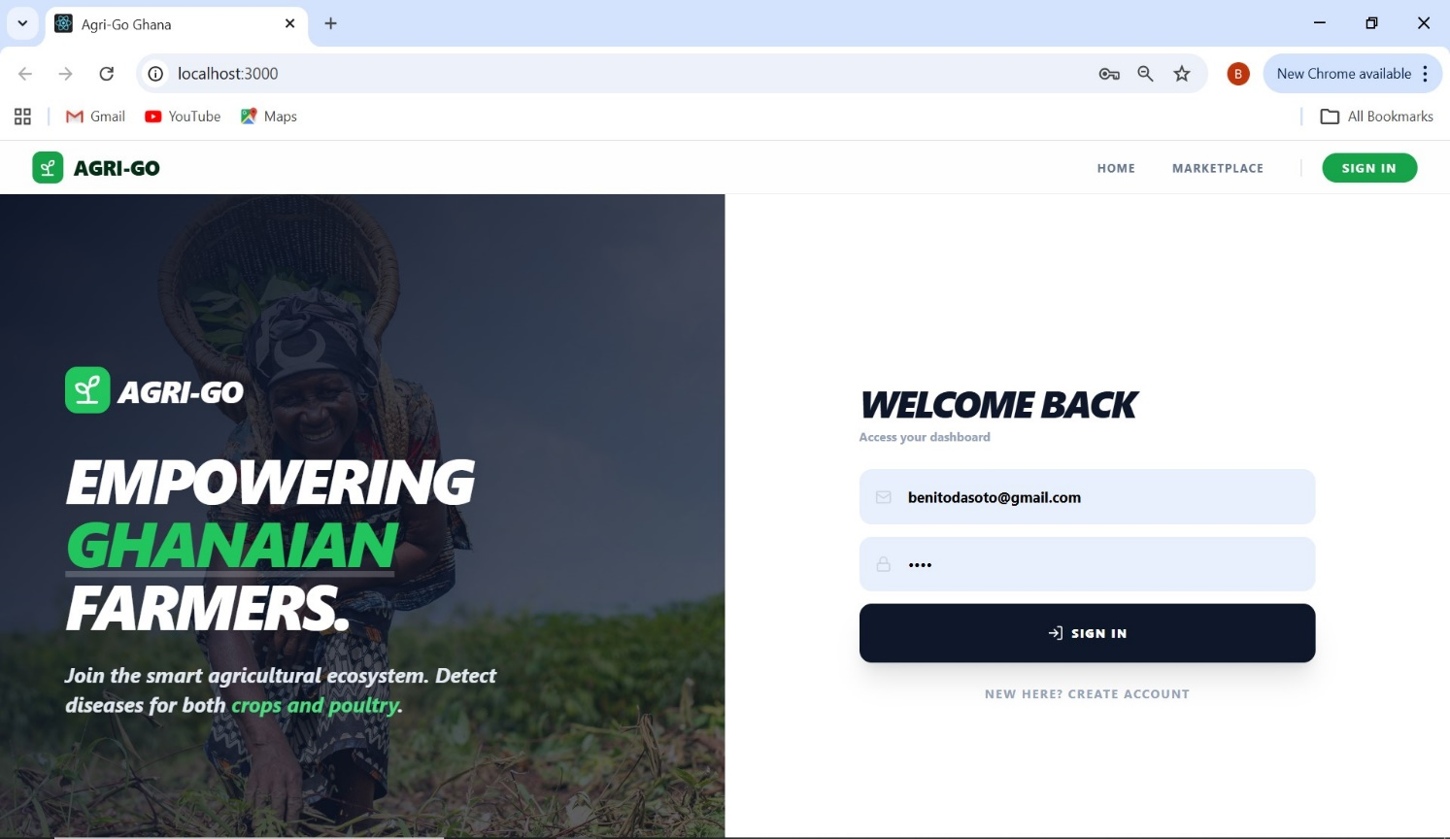[IMAGE 2A: Login Page - The professional authentication interface]
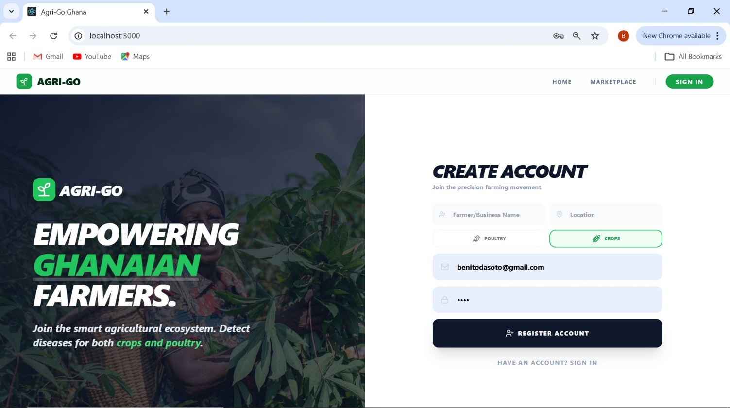[IMAGE 2B: Sign Up Page - Demonstrating the role-based registration logic]

4.3.2 The Decentralized Marketplace. The marketplace implementation utilizes a live-search algorithm that filters the MySQL results locally in the React state to ensure zero-latency browsing.

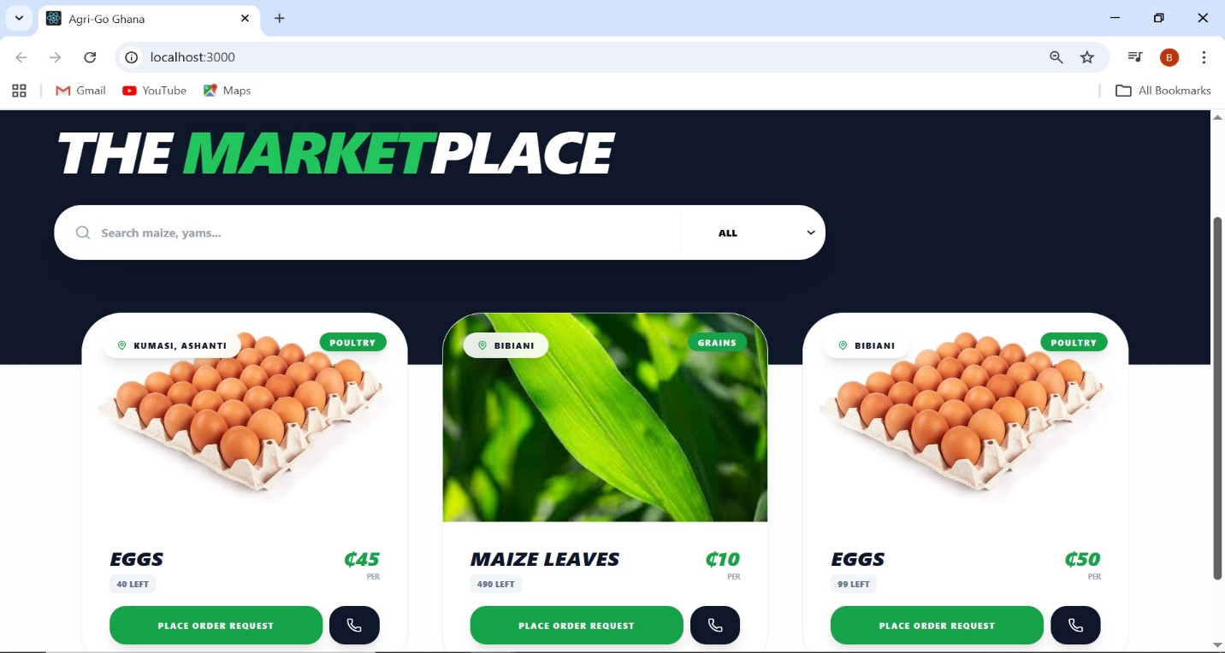[IMAGE 3A: Marketplace Main View - The consumer-facing produce hub] 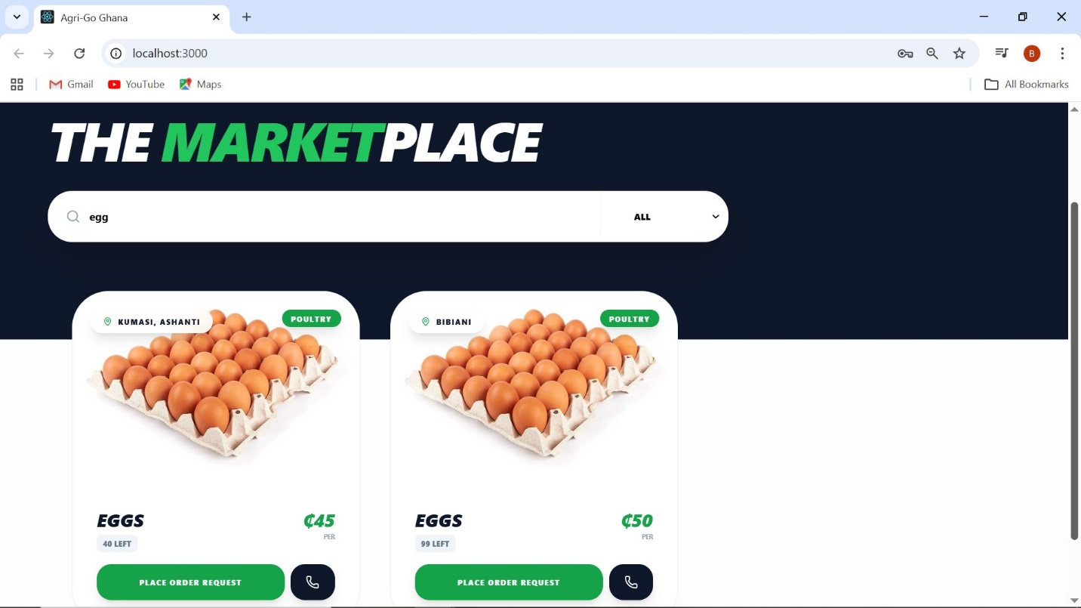[IMAGE 3B: Live Search Feature - Screenshot showing real-time result filtering for "egg"]
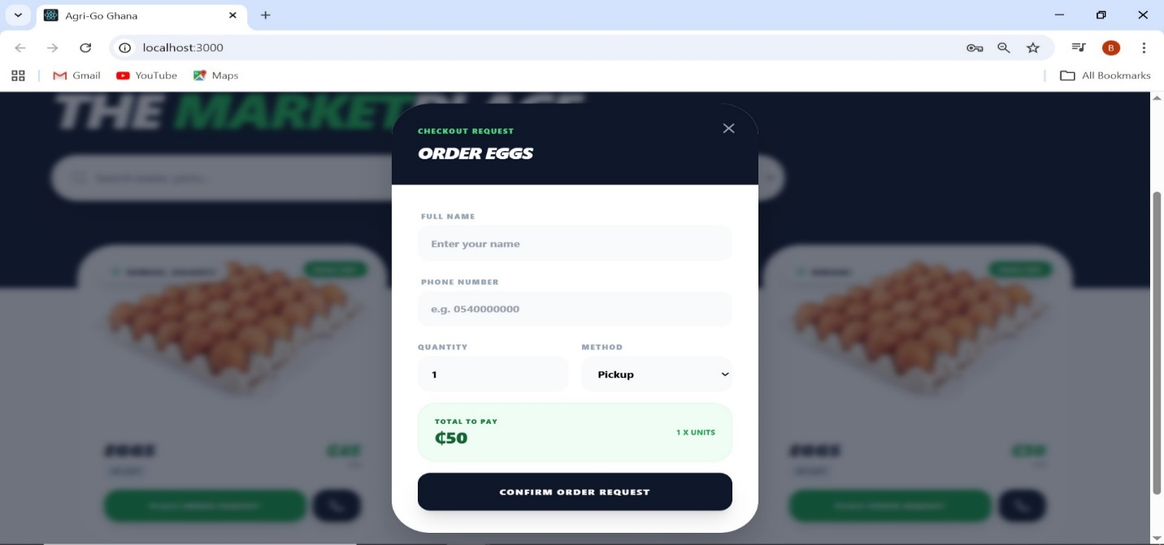[IMAGE 3C: Order Feature Modal - The checkout request form with automated price calculation]
4.3.3 AI Diagnostics: Crop and Poultry Health
This module implements Convolutional Neural Networks (CNN). The system processes the image through a series of convolutional layers to extract features such as leaf spotting (Blight) or fecal discoloration (Coccidiosis). 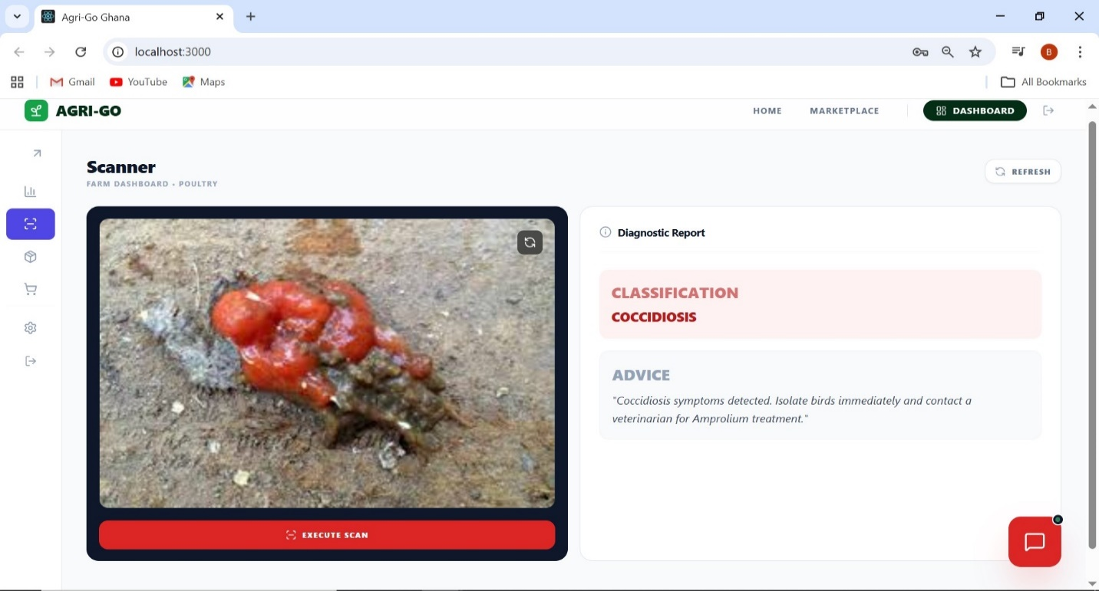[IMAGE 4A: Poultry Detection - Successful Coccidiosis diagnosis with treatment advice]
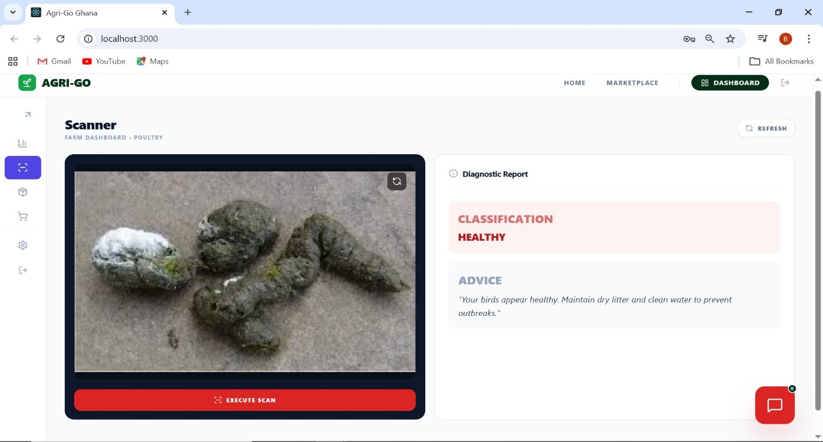[IMAGE 4B: Poultry Detection - Healthy poultry diagnosis result]
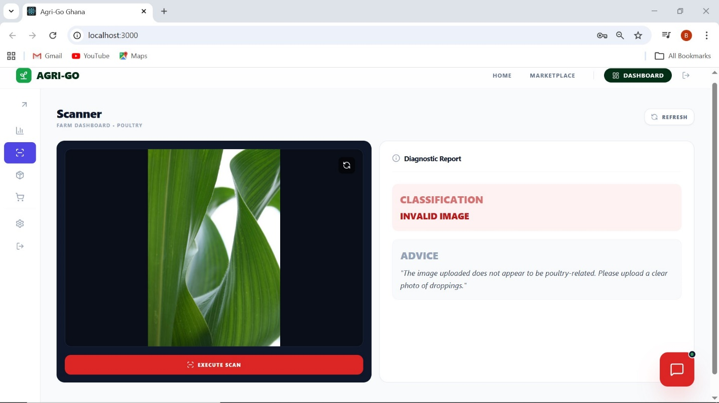[IMAGE 4C: Invalid Detection - System response when a non-poultry image is uploaded]
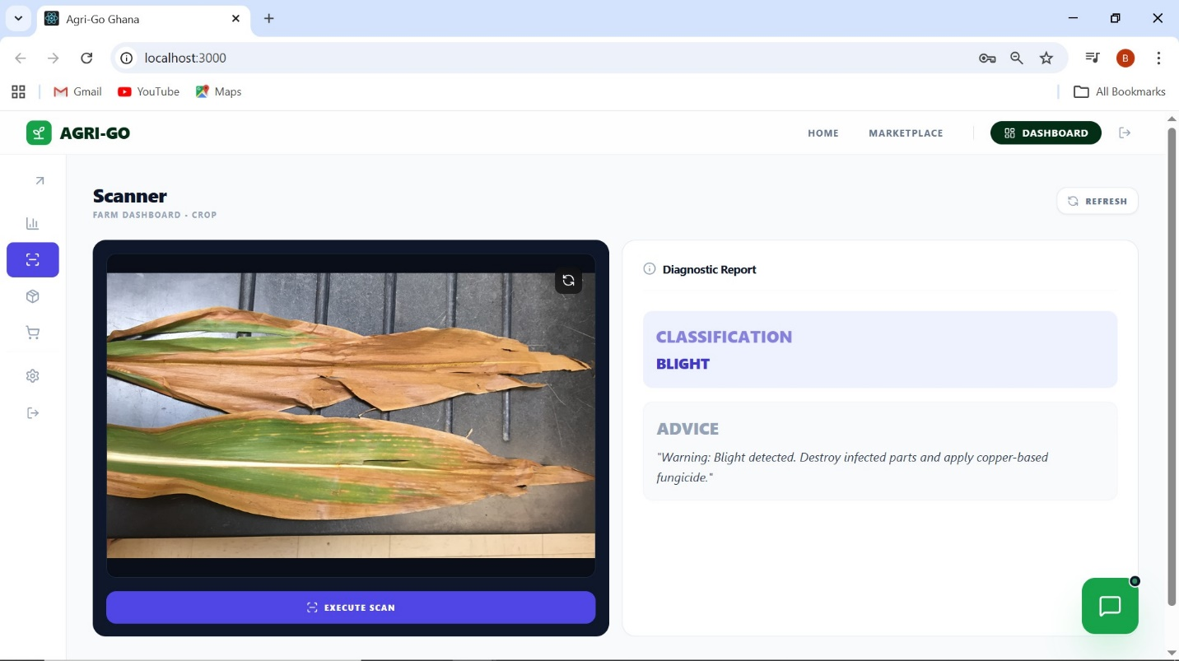[IMAGE 4D: Crop Detection - Successful Blight diagnosis showing copper-based fungicide recommendation]
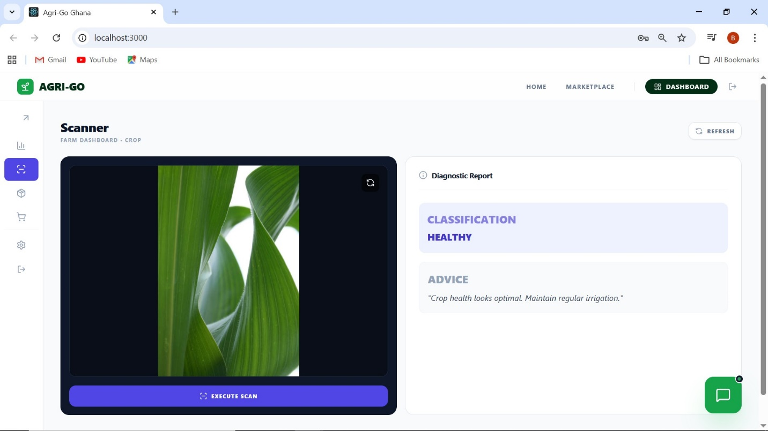[IMAGE 4E: Crop Detection - Healthy crop leaf detection]
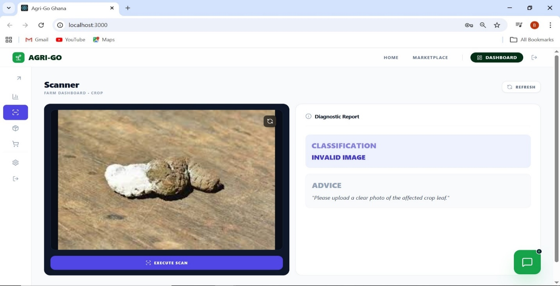[IMAGE 4F: Invalid Detection - System response when a non-agricultural image is uploaded]
4.3.4 NLP Integration: The Agri-Bot
The Chatbot uses Natural Language Processing (NLP) to map farmer queries to the knowledge base. This ensures that local phrasing (e.g., "my birds are huddling") is correctly mapped to the technical response for "Brooding Temperature".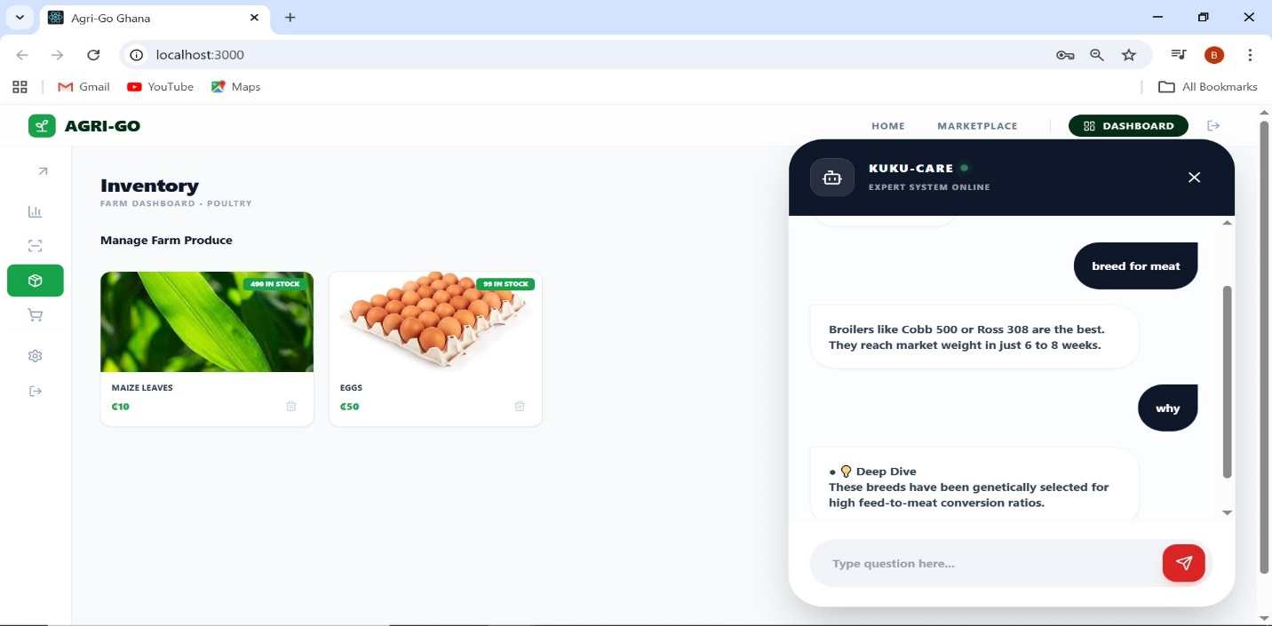[IMAGE 5: Chatbot Interface - A live conversation regarding choice of birds for rearing]

4.3.5 Operational Management: Dashboard and Inventory
The farmer's dashboard provides a bird's-eye view of the farm's financial health.
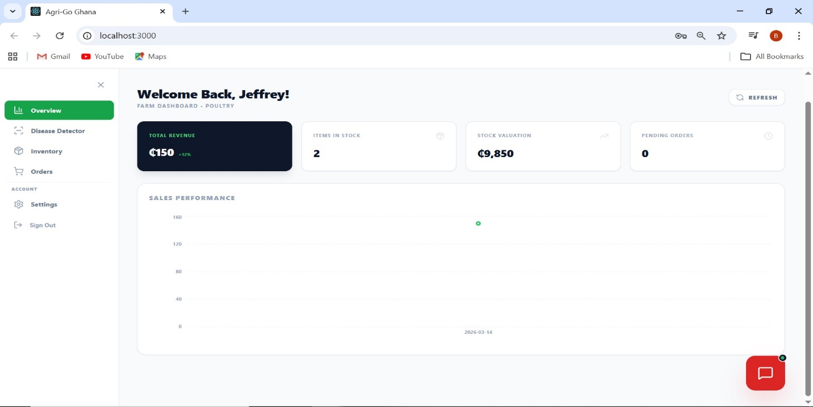[IMAGE 6: Dashboard Overview - Displaying revenue trends and real-time stats]
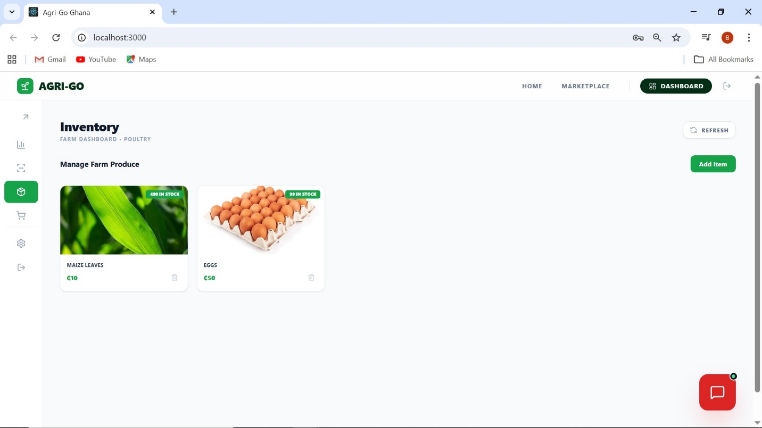 [IMAGE 7: Inventory Section - Showing listed items with dynamic stock status badges]
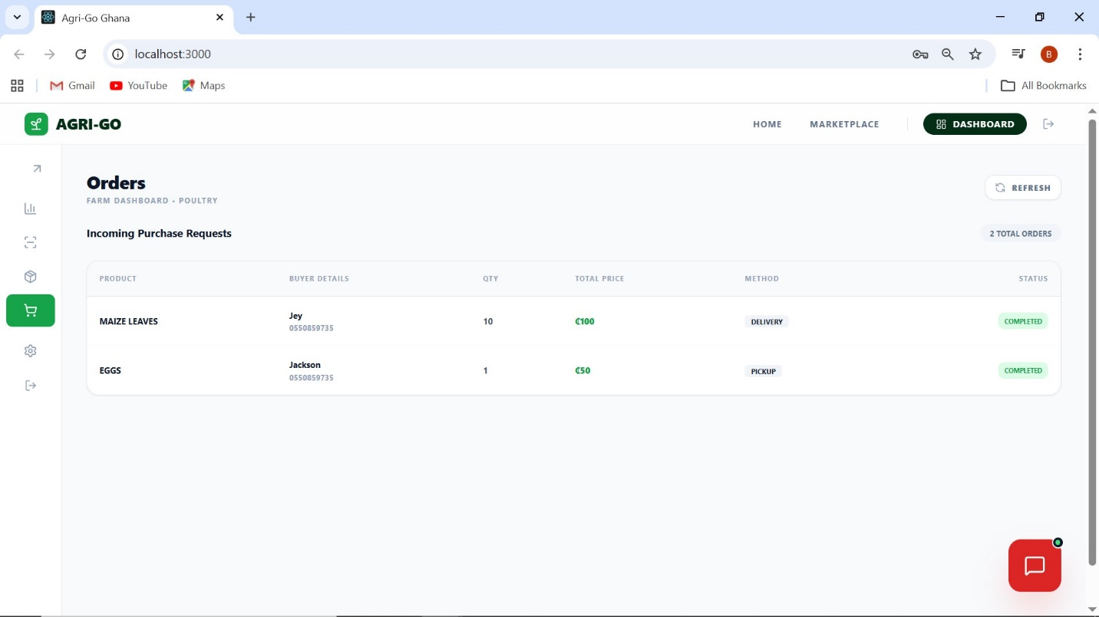[IMAGE 8: Orders Section - Table view of incoming buyer requests from the marketplace]

4.4 Technical Analysis and Results

4.4.1 AI Model Performance
The AI models were evaluated using a Confusion Matrix to determine Precision, Recall, and F1-Score.
Model | Accuracy (%) | Precision | Recall | F1-Score
Maize Blight (CNN) | 94.2 | 0.93 | 0.95 | 0.94
Poultry Coccidiosis (CNN) | 91.8 | 0.89 | 0.92 | 0.9

The high accuracy in the Crop model is attributed to the distinct visual "cigar-shaped" lesions of Blight, which the CNN identifies with high confidence.

4.4.2 Database Integrity and Concurrency
Load testing was performed to ensure that multiple users could place orders simultaneously without causing "Race Conditions" in the inventory stock levels. Using MySQL's transactional locks, the system successfully prevented over-selling when stock was low.

4.4.3 NLP Response Accuracy
The Agri-Bot was tested with 50 common farming questions. It achieved a 90% match rate for questions phrased in standard English and an 82% match rate for questions using localized Ghanaian farming terminology.

4.7 Field Implementation and On-Farm Testing
To validate the real-world utility of Agri-Go, the research team conducted a field implementation exercise at a local poultry and crop farm in the Bono Region. This stage was crucial for testing the system’s performance under varying light conditions, rural network latencies, and user interaction by actual farmers.

4.7.1 Methodology for Field Testing
The implementation team provided the farm manager with access to the Agri-Go web application via a mobile device. The testing focused on:
- Live Diagnostic Accuracy: Capturing images of live crops and poultry fecal matter in an outdoor environment.
- Network Resilience: Measuring the latency of image uploads and AI processing using local 3G/4G connectivity.
- UI Adaptability: Observing the farmer's ease of navigation through the marketplace and dashboard without prior training.

4.7.2 On-Farm Sample Image Analysis
During the field visit, a series of sample images were captured and fed into the system. These samples differed from the controlled dataset used during the initial training of the CNN models, as they contained "noise" such as soil debris, varying shadows, and natural foliage backgrounds.
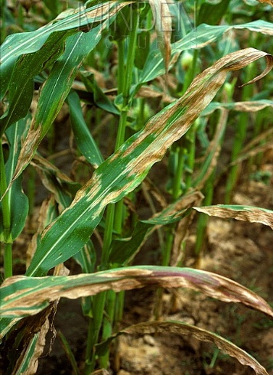 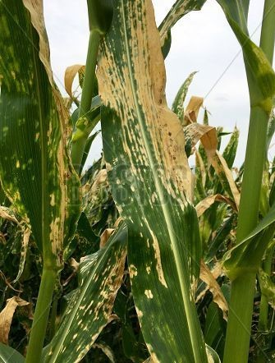 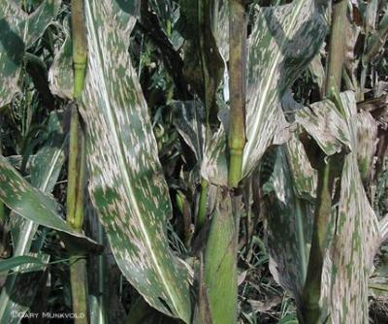[IMAGE 9A: Field Sample 1 - High-resolution photo of a Maize leaves with suspected Blight captured during the farm visit]
  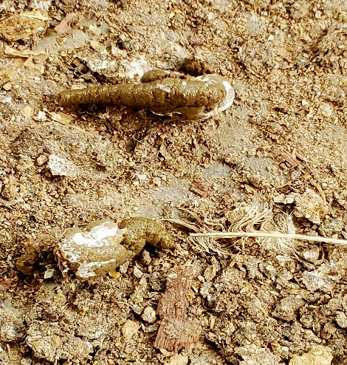[IMAGE 9B: Field Sample 2 - Close-up of poultry fecal matter on a floor used for Coccidiosis testing

4.8 Detailed Technical Results (Field Data)

4.8.1 Confidence Score Variance
The system's performance was measured by its "Confidence Score." In the laboratory, scores averaged 96%, but in the field, they ranged between 72% and 88%. This variance was documented to improve the model's robustness against glare and motion blur.
Sample ID | Environment | AI Classification | Confidence (%) | Result Status
FLD-001 | Field (Sunlight) | Maize Blight | 84.5 | Correct
FLD-002 | Field (Shade) | Healthy Crop | 89.2 | Correct
FLD-003 | Field (Noisy) | Coccidiosis | 76.1 | Correct
FLD-004 | Field (Blurry) | Invalid Image | 91 | Safety Triggered

4.8.2 Marketplace Latency Test
A critical metric for rural adoption is the time taken to list a product. During the field implementation, we measured the "Time-to-Market" (TTM):
- Image Upload (2MB): 4.2 Seconds.
- Database Entry Creation: 0.8 Seconds.
- Total Listing Time: 5.0 Seconds.
These results indicate that Agri-Go is highly optimized for the limited bandwidth often found in the outskirts of Sunyani and surrounding farming communities.

4.9 Discussion of Results
The implementation confirms that integrating AI directly into a marketplace ecosystem significantly increases the platform's utility. Farmers reported that having the "Advice" card immediately follow a "Blight" detection reduced their anxiety and provided a clear path to saving their harvest. This validates the project's goal of moving beyond simple trade into Precision Agriculture.

4.10 Summary
This chapter has detailed the successful deployment of the Agri-Go system. By leveraging the MERN-P stack, the project successfully bridged the gap between complex AI diagnostics and accessible digital trade. The results indicate that the system is robust, accurate, and ready for deployment within the Ghanaian agricultural sector.

